RESOLUTION NO.__________

RE: CERTIFICATE OF APPROPRIATENESS UNDER THE
PROVISIONS OF THE ACT OF THE PENNSYLVANIA
LEGISLATURE 1961, JUNE 13, P.L. 282 (53
SECTION 8004) AND BETHLEHEM ORDINANCE NO.
3952 AS AMENDED.

WHEREAS, it is proposed to demolish the garage at 333 Vine St.

NOW, THEREFORE, BE IT RESOLVED by the Council of the City of Bethlehem that a Certificate of Appropriateness is hereby granted for the work.

Sponsored by: (s)

(s)

ADOPTED BY COUNCIL THIS DAY OF

(s)
President of Council

ATTEST:

(s)
City Clerk

HISTORIC CONSERVATION COMMISSION

CASE # 452 – It is proposed to demolish the garage at 333 Vine St.
OWNER/APPLICANT: Charles & Elena Dziuba

The Commission upon motion by Mr. Loush seconded by Mr. Roeder adopted the proposal that City Council issue a Certificate of Appropriateness for the proposed work described herein:

- The proposal to demolish the garage at 333 Vine St. was presented by Charles & Elena Dziuba.

- The existing early to mid 20th century garage is not a contributing resource in the historic district.

- The garage is undersized and not usable as a garage.

- The garage may be demolished as proposed.

- The existing curb cut will be used to permit off street parking on the existing concrete pad.

- A signed letter of understanding or agreement must be received from the neighbor that states that the wall of the neighboring structure exposed after demolition will be repaired and re-sided in-kind. This letter or agreement must be submitted to the code office before the permit for demolition may be released.

- The existing fence along the sidewalk will be removed.

- The proposed motion was approved by a 5-1 vote. Mr. Silvoy opposed the motion because he thought a letter of agreement with the neighbor should be received by the HCC before giving approval to demolish the garage.

CU: cu

By: 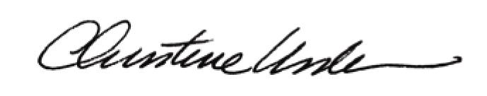

Date of Meeting: May 20, 2013 Title: Historic Officer

